Badminton - Summer Camps 2022

I am running 4 badminton camps during the Summer holidays. The camp will comprise of:
- Coaching & shot practice  - Singles & Doubles (where applicable)  - Fun games  - Competitive games  - A mini tournament in the afternoon  - Suitable for players aged 6 – 15 years | 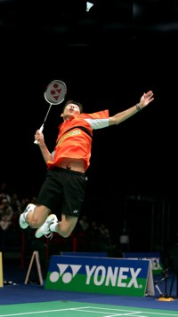

The cost for each day is £25. Summer Camp days are as follows:

Wednesday 3rd August Wednesday 10th August
Wednesday 17th August Wednesday 24th August

Each day will be from 10am-4pm. There will be a short break in the morning and a lunch break before the mini tournament in the afternoon. Players should bring suitable clothing, a packed lunch and enough drink to last the day.

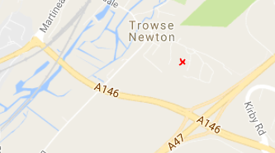 | VENUE:  Trowse Sports Hall,  The Street,  Trowse,  Norwich ,  NR14 8SP

*See the ‘Sweetspot Badminton Coaching’ Facebook page for details of availability.

 | Coach – Ian Murphy, Badminton England Qualified Coach | 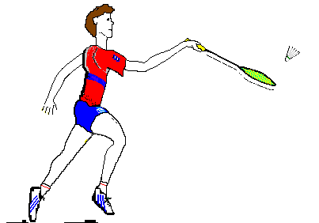
 | Contact: 07789 438567 or smurf-04@tiscali.co.uk

