Norfolk Badminton Association 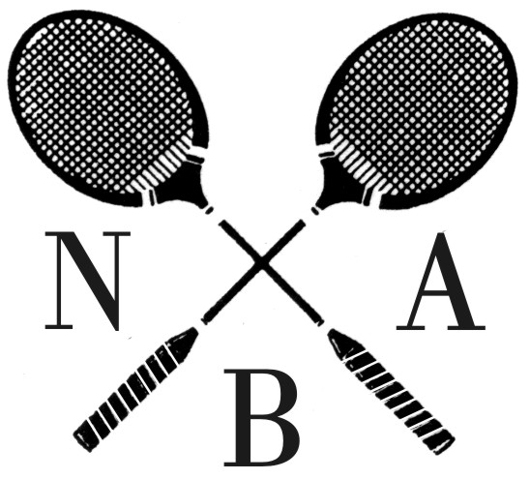

MODERATES TOURNAMENT

Sunday 27th March, 2011
at UEA Sportspark, University of East Anglia, Earlham Rd, Norwich, NR4 7TJ

Programme: Mens & Ladies Doubles 9.45 am. Mixed Doubles 2.15 pm (approx)

Shuttles: Ashaway Tournament Quality Feather

Entry Fee £7.00 per player per event. (Cheques payable to Norfolk Badminton Association)

Rules
1) The tournament will be run in accordance with Badminton England tournament regulations.
2) Players are not eligible to enter if they have played more than one match for a senior county team this season.
3) All entries and fees must be submitted to the secretary by the closing date.
4) Telephone entries will only be accepted if confirmed by the receipt of an entry form and fee before the draw.
5) Any competitor who is unable to play should inform the Tournament Secretary immediately.
6) Entry fees will only be refunded at the discretion of the Committee.
7) All competitors must report to the tournament officials 15 minutes before play starts.
8) Any competitor not ready when called to play will be disqualified.
9) The tournament will be cancelled if insufficient entries are received for each event by the closing date

PLEASE SEND ALL ENTRIES TO: Simon Piff, 11 Proctor Road, Sprowston, Norwich, Norfolk. NR6 7PF
Moderates Tournament Entry Form 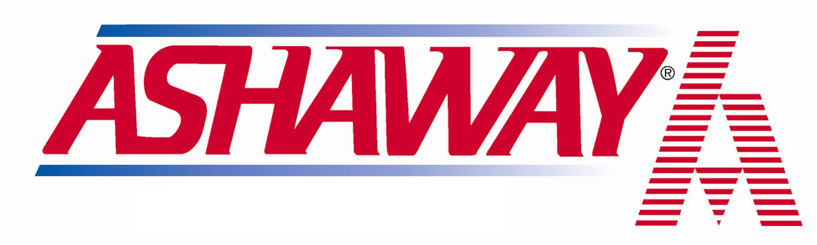
Closing Date: Monday 21st March 2011

Name Mr/Miss/Mrs: Tel. No:

Address:
................................................................................................................................
Postcode:..................EmailAddress:...................................

I am, a member of .......................................... Badminton club

I play in Mixed Division..............................Mens/Ladies Division..........................

Event / Fee Partners Name or Partner wanted Entry fee

Mens Doubles (£7.00)

Ladies Doubles (£7.00)

Mixed Doubles (£7.00)

Signed Date………………………………….

